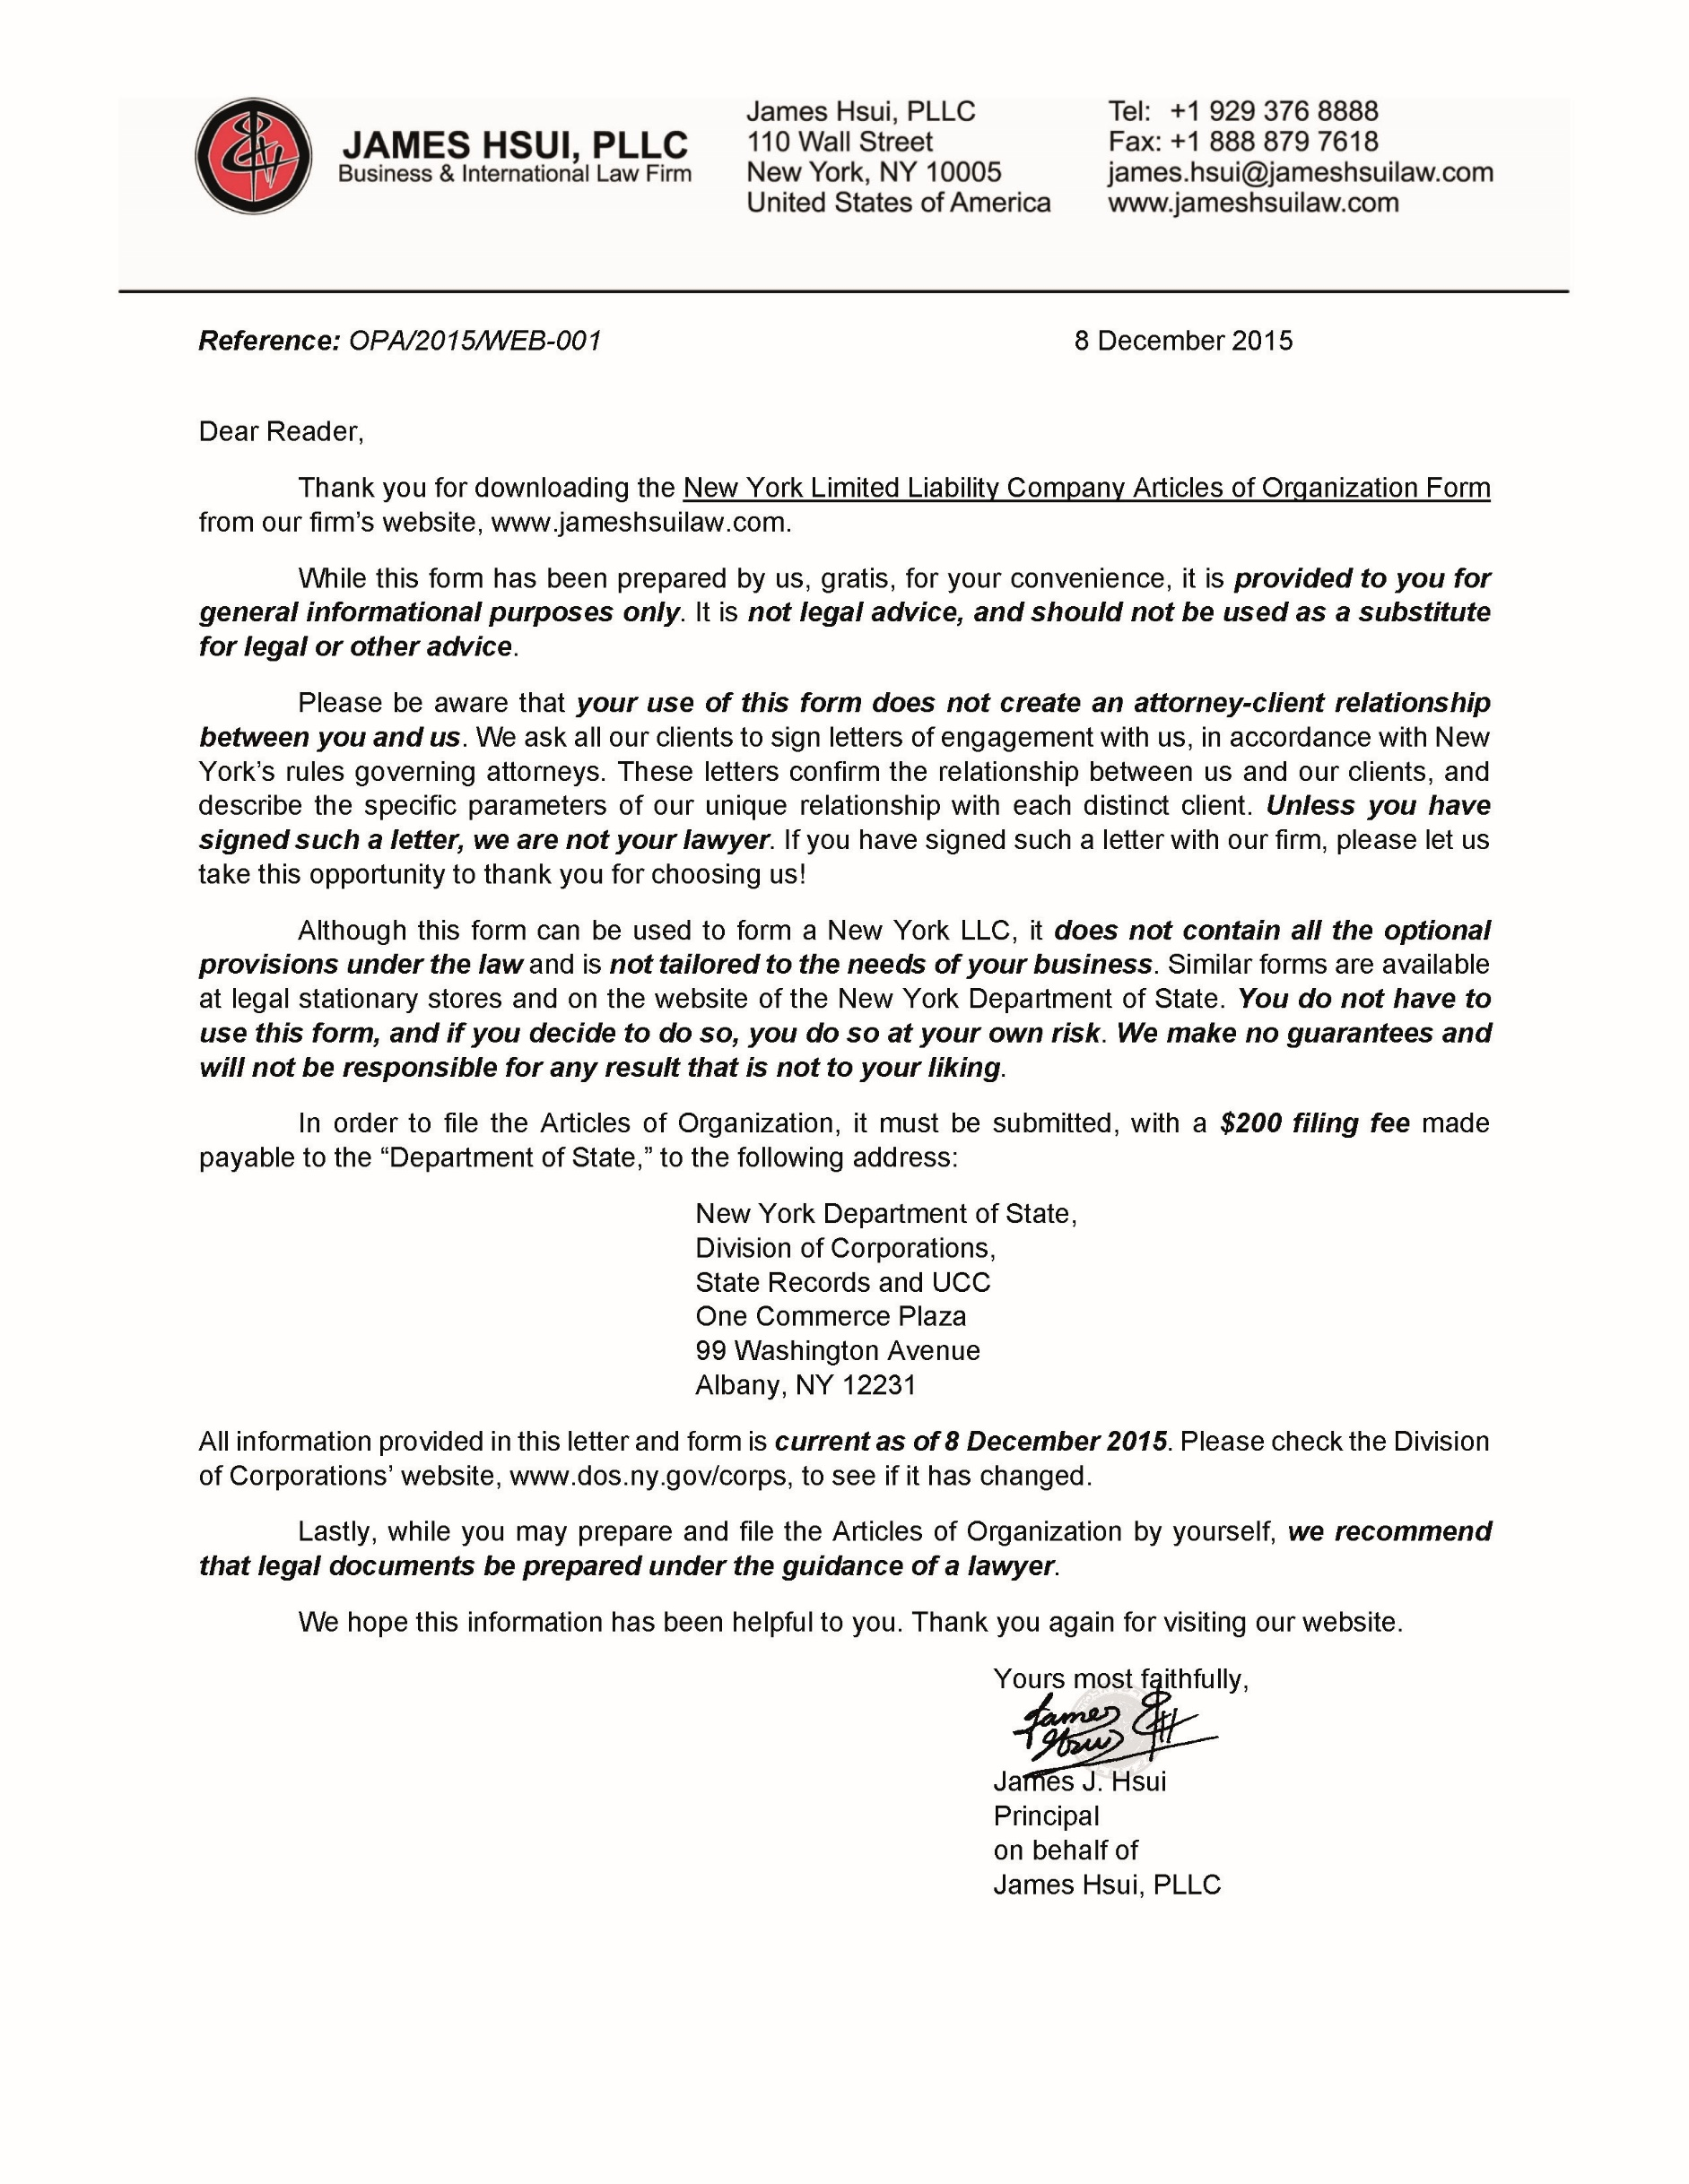
ARTICLES OF ORGANIZATION
OF
[NAME OF COMPANY ENDING WITH LLC]
Under Section 203 of the Limited Liability Company Law of the State of New York

Article I: Name of Company
The name of the Limited Liability Company is [Name of Company ending with LLC] (the “Company”).

Article II: Office of Company
The office of the Company in the State of New York is to be located in [county] county.

Article III: Management of Company
Management of the Company shall be vested in [its Members/a Board of Managers], in accordance with the Operating Agreement of the Company.

Article IV: Designation of Secretary of State as Agent
The New York Secretary of State is designated as agent of the Company, upon whom process against it may be served. The address within or without the State of New York to which the Secretary of State shall mail a copy of any process against the Company served upon him or her is [Address].

Article V: Registered Agent (Optional)
The name and address of the registered agent of the Company in the State of New York is [Name, Address]. The registered agent is designated as agent of the Company, upon whom process against it may be served.

__________________
[Organizer’s Name]
Organizer

ARTICLES OF ORGANIZATION
OF
[NAME OF COMPANY ENDING WITH LLC]
Under Section 203 of the Limited Liability Company Law of the State of New York

FILED BY: [Name of Organizer]
[Address of Organizer]

