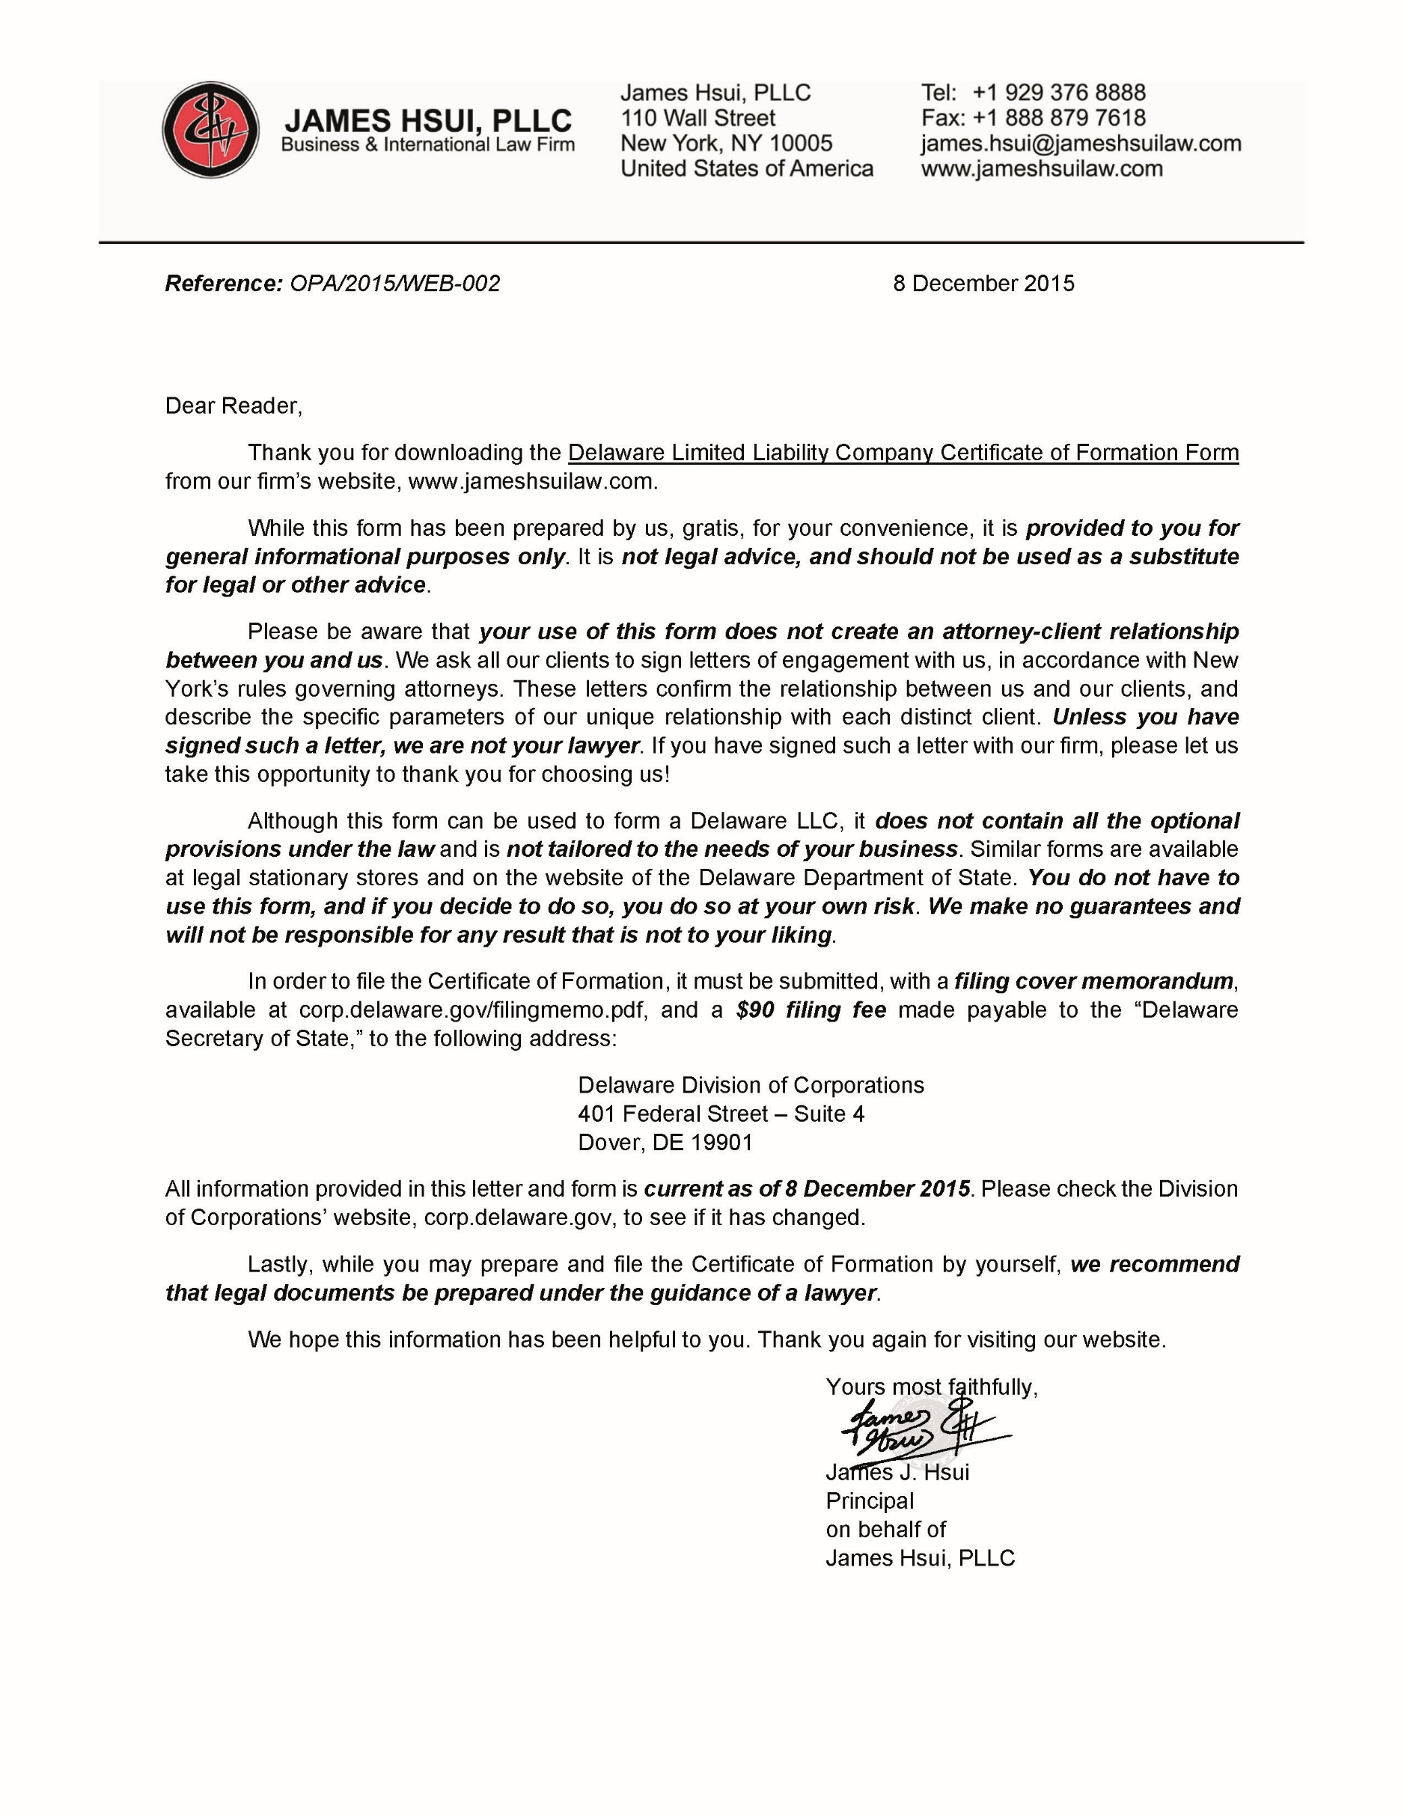

CERTIFICATE OF FORMATION
OF
[NAME OF COMPANY ENDING WITH LLC]

Article I: Name of Company
The name of the Limited Liability Company is [Name of Company ending with LLC] (the “Company”).

Article II: Office of Company
The address of the registered office of the Company in the State of Delaware is [Address of Registered Agent in Delaware], County of [County]. The name of its registered agent at such address is [Name of Registered Agent].

Article III: Duration of the Company
[The existence Company shall be perpetual, unless terminated by agreement of its members in accordance with the limited liability company agreement of the Company or by operation of law. / The latest date on which the Company is to dissolve is [Date].]

Article IV: Miscellaneous Provisions (Optional)

__________________
[Authorized Person’s Name]
Authorized Person

