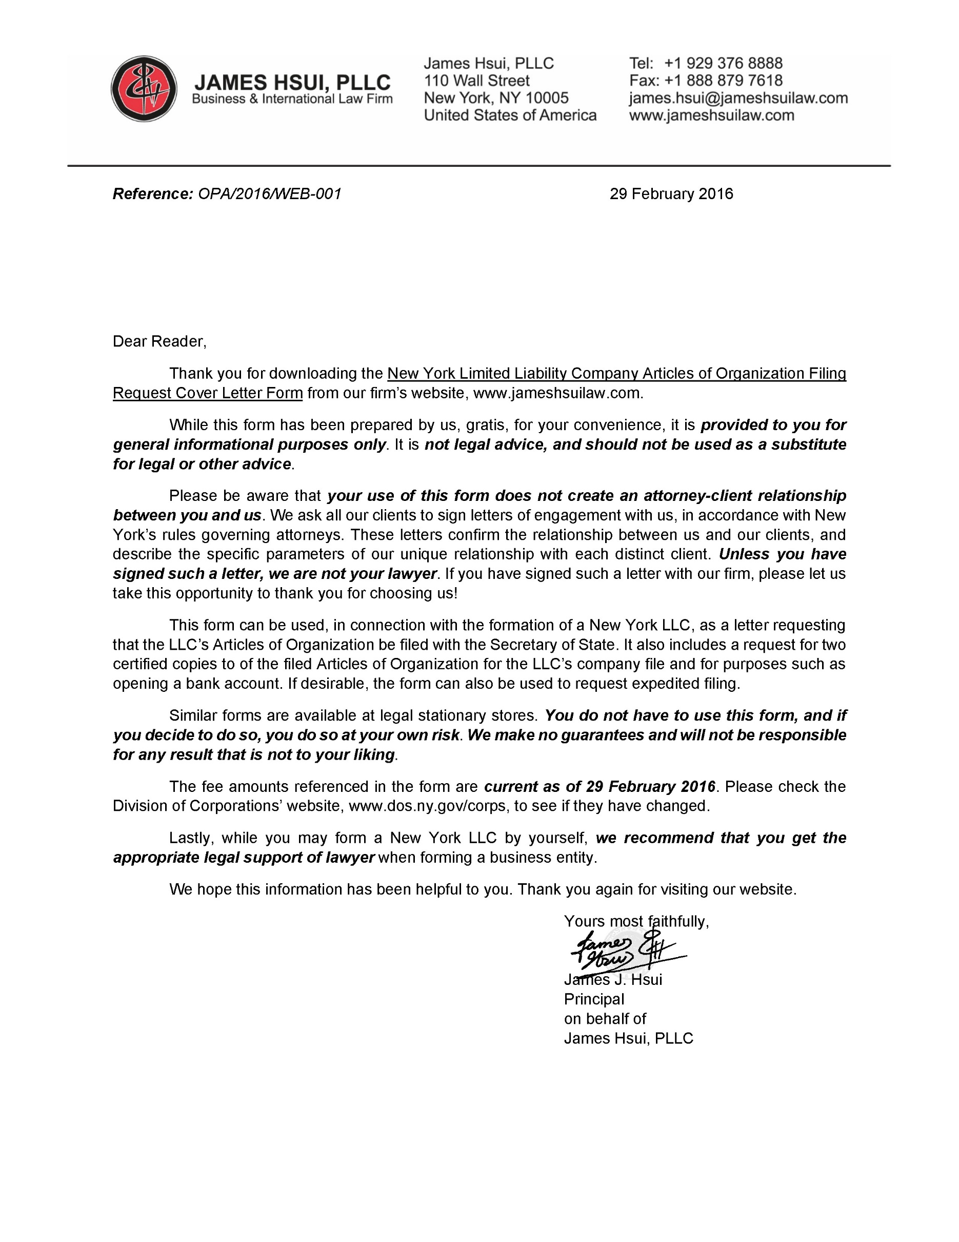
z
[Mailing Address]
[City, State & Zip Code]
3 March 2016
New York Department of State
Division of Corporations
One Commerce Plaza
99 Washington Avenue
Albany, NY 12231

RE: [Expedited ]Filing of Articles of Organization for
[Name of LLC] and Request for Certified Copy
Dear Sir or Madam,
Enclosed please find the following:
- Cover sheet
- Articles of Organization of [Name of LLC]
- Check for $220 ($200 filing fee, plus $20 for two certified copies)
- [Check for $25 (for 24-hour expedited filing)]
Kindly file the Articles of Organization of [Name of LLC][ expeditiously, within 24 hours], and send two (2) certified copies to [name, mailing address, city, state & zip code].
Please call me at [telephone number] if you have any questions or require anything further in connection with this filing request.
Thank you for your kind attention to this matter.
Yours faithfully,
[Signature]
[Name]

ENCL ([3/4])

