Reference: OPA/2018/WEB-003 | 28 February 2018
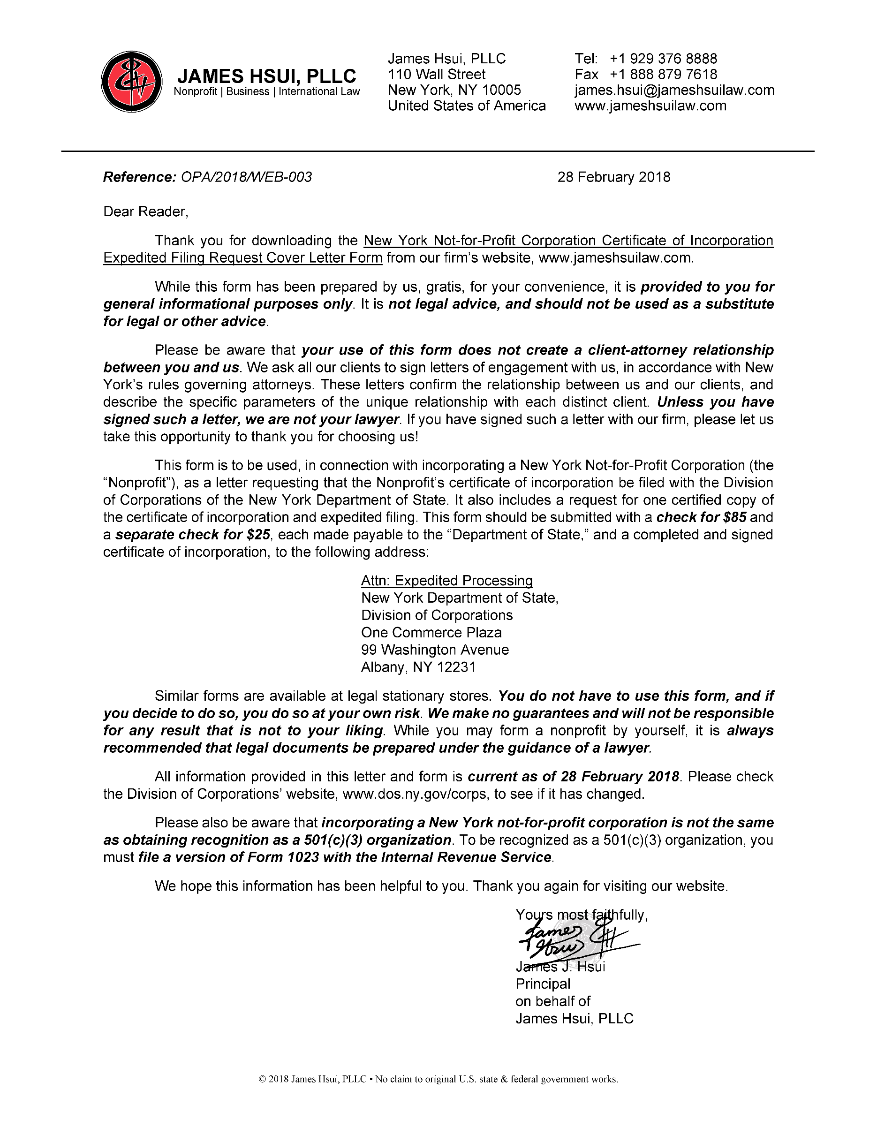
Dear Reader,
Thank you for downloading the New York Not-for-Profit Corporation Certificate of Incorporation Expedited Filing Request Cover Letter Form from our firm’s website, www.jameshsuilaw.com.
While this form has been prepared by us, gratis, for your convenience, it is provided to you for general informational purposes only. It is not legal advice, and should not be used as a substitute for legal or other advice.
Please be aware that your use of this form does not create a client-attorney relationship between you and us. We ask all our clients to sign letters of engagement with us, in accordance with New York’s rules governing attorneys. These letters confirm the relationship between us and our clients, and describe the specific parameters of the unique relationship with each distinct client. Unless you have signed such a letter, we are not your lawyer. If you have signed such a letter with our firm, please let us take this opportunity to thank you for choosing us!
This form is to be used, in connection with incorporating a New York Not-for-Profit Corporation (the “Nonprofit”), as a letter requesting that the Nonprofit’s certificate of incorporation be filed with the Division of Corporations of the New York Department of State. It also includes a request for one certified copy of the certificate of incorporation and expedited filing. This form should be submitted with a check for $85 and a separate check for $25, each made payable to the “Department of State,” and a completed and signed certificate of incorporation, to the following address:
Attn: Expedited Processing
New York Department of State,
Division of Corporations
One Commerce Plaza
99 Washington Avenue
Albany, NY 12231
Similar forms are available at legal stationary stores. You do not have to use this form, and if you decide to do so, you do so at your own risk. We make no guarantees and will not be responsible for any result that is not to your liking. While you may form a nonprofit by yourself, it is always recommended that legal documents be prepared under the guidance of a lawyer.
All information provided in this letter and form is current as of 28 February 2018. Please check the Division of Corporations’ website, www.dos.ny.gov/corps, to see if it has changed.
Please also be aware that incorporating a New York not-for-profit corporation is not the same as obtaining recognition as a 501(c)(3) organization. To be recognized as a 501(c)(3) organization, you must file a version of Form 1023 with the Internal Revenue Service.
We hope this information has been helpful to you. Thank you again for visiting our website.
Yours most faithfully,
James J. Hsui
Principal
on behalf of
James Hsui, PLLC
[Mailing Address]

1 April 2022
Attn: Expedited Processing
New York Department of State
Division of Corporations
One Commerce Plaza
99 Washington Avenue
Albany, NY 12231
RE: Expedited Filing of Not-for-Profit Corporation
Certificate of Incorporation of
[Name of Corporation]
and Request for Certified Copy
Dear Sir or Madam,
Enclosed please find the following:
- Cover sheet;
- Certificate of incorporation of the above referenced not-for-profit corporation;
- Check for the sum of $85, consisting of fees for filing of the certificate of incorporation of a not-for-profit corporation, for one (1) certified copy; and
- Check for the sum of $25, consisting of the fee for expedited filing.
Kindly file the above referenced certificate of incorporation, and send the certified copy to the following address:
[Name]
[Mailing Address]

Please call me at [Telephone Number] if you have any questions or require anything further in connection with this filing request.
Thank you for your kind attention to this matter.
Yours faithfully,
[Name]

Enclosed: (4)

