Reference: OPA/2018/WEB-006 | 28 February 2018
Dear Reader,
Thank you for downloading the Basic 501(c)(3) Conflicts of Interest Policy Form from our firm’s website, www.jameshsuilaw.com.
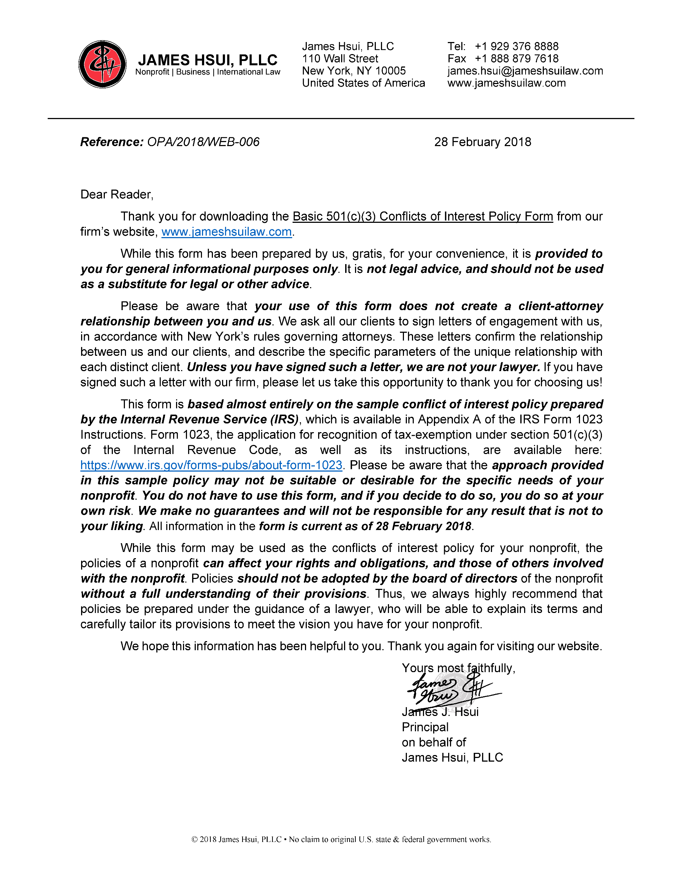
While this form has been prepared by us, gratis, for your convenience, it is provided to you for general informational purposes only. It is not legal advice, and should not be used as a substitute for legal or other advice.
Please be aware that your use of this form does not create a client-attorney relationship between you and us. We ask all our clients to sign letters of engagement with us, in accordance with New York’s rules governing attorneys. These letters confirm the relationship between us and our clients, and describe the specific parameters of the unique relationship with each distinct client. Unless you have signed such a letter, we are not your lawyer. If you have signed such a letter with our firm, please let us take this opportunity to thank you for choosing us!
This form is based almost entirely on the sample conflict of interest policy prepared by the Internal Revenue Service (IRS), which is available in Appendix A of the IRS Form 1023 Instructions. Form 1023, the application for recognition of tax-exemption under section 501(c)(3) of the Internal Revenue Code, as well as its instructions, are available here: https://www.irs.gov/forms-pubs/about-form-1023. Please be aware that the approach provided in this sample policy may not be suitable or desirable for the specific needs of your nonprofit. You do not have to use this form, and if you decide to do so, you do so at your own risk. We make no guarantees and will not be responsible for any result that is not to your liking. All information in the form is current as of 28 February 2018.
While this form may be used as the conflicts of interest policy for your nonprofit, the policies of a nonprofit can affect your rights and obligations, and those of others involved with the nonprofit. Policies should not be adopted by the board of directors of the nonprofit without a full understanding of their provisions. Thus, we always highly recommend that policies be prepared under the guidance of a lawyer, who will be able to explain its terms and carefully tailor its provisions to meet the vision you have for your nonprofit.
We hope this information has been helpful to you. Thank you again for visiting our website.
Yours most faithfully,

James J. Hsui
Principal
on behalf of
James Hsui, PLLC

CONFLICTs OF INTEREST POLICY

OF
[Name of Corporation]

INTERPRETATION

Definitions
In this conflicts of interest policy, the following terms shall have the following meanings:
“Board” means the board of directors of the Corporation.
“Committee” means a committee, established by the Board, with Board delegated power.
“Compensation” means includes direct and indirect remuneration as well as gifts or favors that are not insubstantial.
“Corporation” means [Name of Corporation], a corporation organized and existing under the laws of the State of [State of Incorporation].
“Covered Person” means any director, principal officer, or member of a Committee.
“Entity” means a Person other than an Individual.
“Financial Interest” means, with respect to a Person, that the Person has, directly or indirectly, through business, investment, or family:

an ownership or investment interest in any Entity with which the Corporation has a transaction or arrangement;

a Compensation arrangement with the Corporation or with any Person with which the Corporation has a transaction or arrangement; or

a potential ownership or investment interest in, or Compensation arrangement with, any Person with which the Corporation is negotiating a transaction or arrangement.
“Individual” means a human being.
“Interested Person” means any Covered Person, who has a direct or indirect Financial Interest.
“Person” means an Individual, partnership, limited partnership, limited liability partnership, limited liability company, association, firm, company, corporation, trust, association, state or public agency or instrumentality, or any other entity.
“Policy” means this conflicts of interest policy.

Purpose
The purpose of this Policy is to protect the Corporation’s interest when it is contemplating entering into a transaction or arrangement that might benefit the private interest of a Covered Person or that might result in a possible excess benefit transaction. This Policy is intended to supplement but not replace any applicable state and federal laws governing conflict of interest applicable to nonprofit and charitable organizations.

Financial Interest Not Always a Conflict of Interest
A Financial Interest is not necessarily a conflict of interest. Under Section 2.3 of this Policy, below, a Person who has a Financial Interest may have a conflict of interest only if the Board or an appropriate Committee decides that a conflict of interest exists.

Procedures

Duty to Disclose
In connection with any actual or possible conflict of interest, an Interested Person must disclose the existence of the Financial Interest and be given the opportunity to disclose all material facts to the Board or to the Committee considering the proposed transaction or arrangement.

Preclusion from Discussions and Voting
No Covered Person who receives Compensation, directly or indirectly, from the Corporation, may vote on, or participate in discussions, on matters pertaining to such Covered Person’s Compensation. However, nothing in this Section shall be deemed to preclude a Covered Person from making the proper disclosures and appropriate presentations to the Board or Committee as described in Section 2.1 and Section 2.4(a) of this Policy, or otherwise providing information to said Board or Committee regarding such Covered Person’s Compensation.

Determining if a Conflict of Interest Exists
After disclosure of the Financial Interest and all material facts, and after any discussion with the Interested Person, the Interested Person shall leave the meeting of the Board or Committee while the determination of a conflict of interest is discussed and voted upon. The remaining members of the Board or Committee shall decide if a conflict of interest exists.

Addressing the Conflict of Interest
In the event an actual or possible conflict of interest is found to exist pursuant to Section 2.3 of this Policy, the conflict of interest shall be addressed and resolved, in the best interest of the Corporation, in the following manner:

An Interested Person may make a presentation at the Board or Committee meeting, but after the presentation, the Interested Person shall leave the meeting during the discussion of, and the vote on, the transaction or arrangement involving the conflict of interest;

The Individual presiding over such meeting shall, if appropriate, appoint a disinterested person or Committee to investigate alternatives to the proposed transaction or arrangement;

After exercising due diligence, the Board or Committee shall determine whether the Corporation can obtain, with reasonable efforts, a more advantageous transaction or arrangement from a Person that would not give rise to a conflict of interest; and

If a more advantageous transaction or arrangement is not reasonably possible under circumstances not producing a conflict of interest, the Board or Committee shall determine by a majority vote of its disinterested members whether the transaction or arrangement is in the Corporation’s best interest, for its own benefit, and whether it is fair and reasonable. In conformity with the above determination, it shall make its decision as to whether to enter into the transaction or arrangement.

Violations of Policy
If the Board or Committee has reasonable cause to believe a Covered Person has failed to disclose actual or possible conflicts of interest, it shall inform the Covered Person of the basis for such belief and afford the Covered Person an opportunity to explain the alleged failure to disclose. If, after hearing the Covered Person’s response and after making further investigation as warranted by the circumstances, the Board or Committee determines that the member has failed to disclose an actual or possible conflict of interest, it shall take appropriate disciplinary and corrective action.

Record Keeping

Records of Proceedings
The minutes of the Board and all Committees shall contain:

The names of the Covered Persons who disclosed or otherwise were found to have a Financial Interest in connection with an actual or possible conflict of interest, the nature of the Financial Interest, any action taken to determine whether a conflict of interest was present, and the decision of the Board or Committee as to whether a conflict of interest in fact existed.

The names of the Individuals who were present for discussions and votes relating to the transaction or arrangement, the content of the discussion, including any alternatives to the proposed transaction or arrangement, and a record of any votes taken in connection with the proceedings.

Annual Statements
Each Covered Person shall annually sign a statement which affirms such Covered Person:

Has received a copy of this Policy,

Has read and understands this Policy,

Has agreed to comply with this Policy, and

Understands the Corporation is charitable and in order to maintain its federal tax exemption it must engage primarily in activities that accomplish one or more of its tax-exempt purposes.

Review of Arrangements

Periodic Reviews
To ensure the Corporation operates in a manner consistent with tax-exempt purposes, and does not engage in activities that could jeopardize its tax-exempt status, periodic reviews shall be conducted. The periodic reviews shall, at a minimum, include the following subjects:

Whether Compensation arrangements and benefits are reasonable, based on competent survey information, and the result of arm's length bargaining.

Whether partnerships, joint ventures, and arrangements with management organizations conform to the Corporation's written policies, are properly recorded, reflect reasonable investment or payments for goods and services, further charitable purposes and do not result in inurement, impermissible private benefit, or in an excess benefit transaction.

Use of Outside Experts
When conducting the periodic reviews, as provided for in Section 4.1 of this Policy, the Corporation may, but need not, use outside advisors. If outside experts are used, their use shall not relieve the Board of its responsibility for ensuring periodic reviews are conducted.
POLICY ADOPTION CERTIFICATE
I, [Name of Secretary], the undersigned, do hereby certify the following:
- I am the duly appointed Secretary of [Name of Corporation] (the “Corporation”);
- I am authorized to execute this certificate on behalf of the Corporation; and
- the foregoing conflicts of interest policy, comprising of 5 pages, including this page, constitute the conflicts of interest policy of the Corporation as of the ________ day of ________________, 20________, duly adopted by the board of directors of the Corporation.
IN WITNESS WHEREOF, I have executed this certificate as of the ________ day of ________________, 20________.

_____________________
[Name of Secretary]
Secretary

